Data Transfer Object (DTO)

📝Definition
# Source: AI Source: Provided by: [Data Path: Persons Table -> ID Column: 1, Name_En Column: Motasem Essam] -> From: [ChatGPT] on [1/23/2026]
A Data Transfer Object (DTO) is a simple object used to transfer data between layers or systems without containing business logic.
👉 DTO = data carrier only (no behavior)

🔑 Key Characteristics
# Source: AI Source: Provided by: [Data Path: Persons Table -> ID Column: 1, Name_En Column: Motasem Essam] -> From: [ChatGPT] on [1/23/2026]
- ✅ Contains data only
- ❌ No business logic
- ✅ Used for communication between layers (Controller ↔ Service ↔ API)
- ✅ Often flattened/simplified structure

🧱 Example
# Source: AI Source: Provided by: [Data Path: Persons Table -> ID Column: 1, Name_En Column: Motasem Essam] -> From: [ChatGPT] on [1/23/2026]
class UserDTO {
public String name;
public int age;
}
👉 Used to send/receive data, not to process it

🧩 Real Usage Example

Controller
# Source: AI Source: Provided by: [Data Path: Persons Table -> ID Column: 1, Name_En Column: Motasem Essam] -> From: [ChatGPT] on [1/23/2026]
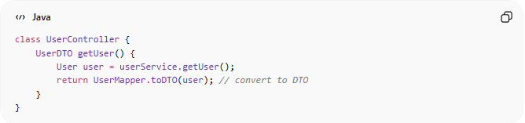
class UserController {
UserDTO getUser() {
User user = userService.getUser();
return UserMapper.toDTO(user); // convert to DTO
}
}

Mapper
# Source: AI Source: Provided by: [Data Path: Persons Table -> ID Column: 1, Name_En Column: Motasem Essam] -> From: [ChatGPT] on [1/23/2026]
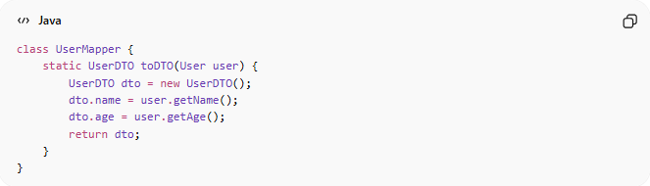
class UserMapper {
static UserDTO toDTO(User user) {
UserDTO dto = new UserDTO();
dto.name = user.getName();
dto.age = user.getAge();
return dto;
}
}

❌ Bad Example (DTO with Logic)
# Source: AI Source: Provided by: [Data Path: Persons Table -> ID Column: 1, Name_En Column: Motasem Essam] -> From: [ChatGPT] on [1/23/2026]
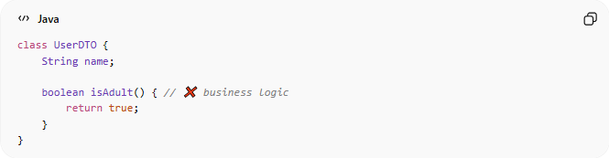
class UserDTO {
String name;

boolean isAdult() { // ❌ business logic
return true;
}
}
👉 Problems:
- Violates DTO purpose
- Mixes layers
- Hard to maintain

✅ Good Example (Clean DTO)
# Source: AI Source: Provided by: [Data Path: Persons Table -> ID Column: 1, Name_En Column: Motasem Essam] -> From: [ChatGPT] on [1/23/2026]
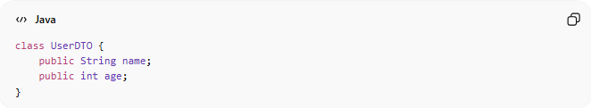
class UserDTO {
public String name;
public int age;
}
👉 Benefits:
- Simple and clear
- Easy to serialize (JSON/XML)
- Safe for APIs

🔄 DTO vs Other Models
# Source: AI Source: Provided by: [Data Path: Persons Table -> ID Column: 1, Name_En Column: Motasem Essam] -> From: [ChatGPT] on [1/23/2026]
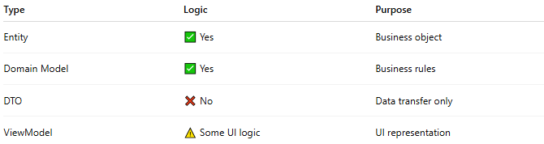
Type | Logic | Purpose
Entity | ✅ Yes | Business object
Domain Model | ✅ Yes | Business rules
DTO | ❌ No | Data transfer only
ViewModel | ⚠️ Some UI logic | UI representation

🔄 When to Use DTO
# Source: AI Source: Provided by: [Data Path: Persons Table -> ID Column: 1, Name_En Column: Motasem Essam] -> From: [ChatGPT] on [1/23/2026]
- Sending data in API responses
- Receiving data in API requests
- Transferring data between layers
- Hiding internal domain structure

⚠️ Common Mistakes
# Source: AI Source: Provided by: [Data Path: Persons Table -> ID Column: 1, Name_En Column: Motasem Essam] -> From: [ChatGPT] on [1/23/2026]
- Adding business logic to DTO ❌
- Using Entity directly in APIs ❌
- Creating too many unnecessary DTOs ❌

💡 Key Idea
# Source: AI Source: Provided by: [Data Path: Persons Table -> ID Column: 1, Name_En Column: Motasem Essam] -> From: [ChatGPT] on [1/23/2026]
DTO = structure for communication, not for behavior

🔄 Data Transfer Object vs Mappers

🧠 Key Difference
# Source: AI Source: Provided by: [Data Path: Persons Table -> ID Column: 1, Name_En Column: Motasem Essam] -> From: [ChatGPT] on [1/23/2026]
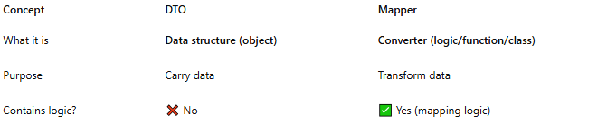
Concept | DTO | Mapper
What it is | Data structure (object) | Converter (logic/function/class)
Purpose | Carry data | Transform data
Contains logic? | ❌ No | ✅ Yes (mapping logic)

🧩 Simple Explanation
# Source: AI Source: Provided by: [Data Path: Persons Table -> ID Column: 1, Name_En Column: Motasem Essam] -> From: [ChatGPT] on [1/23/2026]
- DTO 👉 “What data looks like”
- Mapper 👉 “How to convert data”

🧱 Example Together

DTO
# Source: AI Source: Provided by: [Data Path: Persons Table -> ID Column: 1, Name_En Column: Motasem Essam] -> From: [ChatGPT] on [1/23/2026]
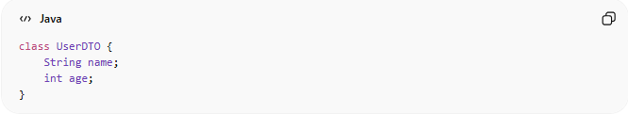
class UserDTO {
String name;
int age;
}

Entity (Domain Model)
# Source: AI Source: Provided by: [Data Path: Persons Table -> ID Column: 1, Name_En Column: Motasem Essam] -> From: [ChatGPT] on [1/23/2026]
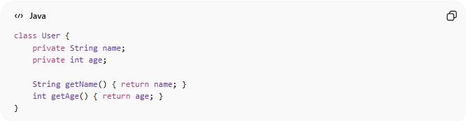
class User {
private String name;
private int age;

String getName() { return name; }
int getAge() { return age; }
}

Mapper
# Source: AI Source: Provided by: [Data Path: Persons Table -> ID Column: 1, Name_En Column: Motasem Essam] -> From: [ChatGPT] on [1/23/2026]
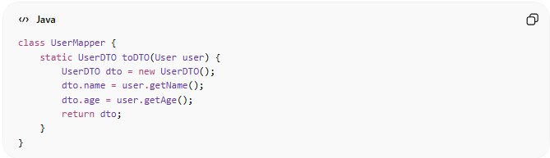
class UserMapper {
static UserDTO toDTO(User user) {
UserDTO dto = new UserDTO();
dto.name = user.getName();
dto.age = user.getAge();
return dto;
}
}

🔄 Flow
# Source: AI Source: Provided by: [Data Path: Persons Table -> ID Column: 1, Name_En Column: Motasem Essam] -> From: [ChatGPT] on [1/23/2026]
User (Entity) → Mapper → UserDTO
👉 DTO = result
👉 Mapper = process

❌ Common Mistake
# Source: AI Source: Provided by: [Data Path: Persons Table -> ID Column: 1, Name_En Column: Motasem Essam] -> From: [ChatGPT] on [1/23/2026]
Putting mapping inside DTO ❌
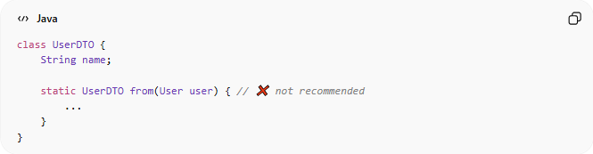
class UserDTO {
String name;

static UserDTO from(User user) { // ❌ not recommended
...
}
}
👉 This mixes responsibilities

✅ Good Practice
# Source: AI Source: Provided by: [Data Path: Persons Table -> ID Column: 1, Name_En Column: Motasem Essam] -> From: [ChatGPT] on [1/23/2026]
DTO → only data
Mapper → only conversion logic
👉 Clear separation = Clean Code

💡 Easy Analogy
# Source: AI Source: Provided by: [Data Path: Persons Table -> ID Column: 1, Name_En Column: Motasem Essam] -> From: [ChatGPT] on [1/23/2026]
- DTO = 📦 Box (holds data)
- Mapper = 🔄 Worker (moves data into the box)

🧾 Summary
# Source: AI Source: Provided by: [Data Path: Persons Table -> ID Column: 1, Name_En Column: Motasem Essam] -> From: [ChatGPT] on [1/23/2026]
- DTO ≠ Mapper ❌
- DTO = data container
- Mapper = data transformer
- They work together but have different roles

🧾 Summary
# Source: AI Source: Provided by: [Data Path: Persons Table -> ID Column: 1, Name_En Column: Motasem Essam] -> From: [ChatGPT] on [1/23/2026]
DTO:
- Transfers data between layers/systems
- Contains no business logic
- Keeps architecture clean and decoupled

